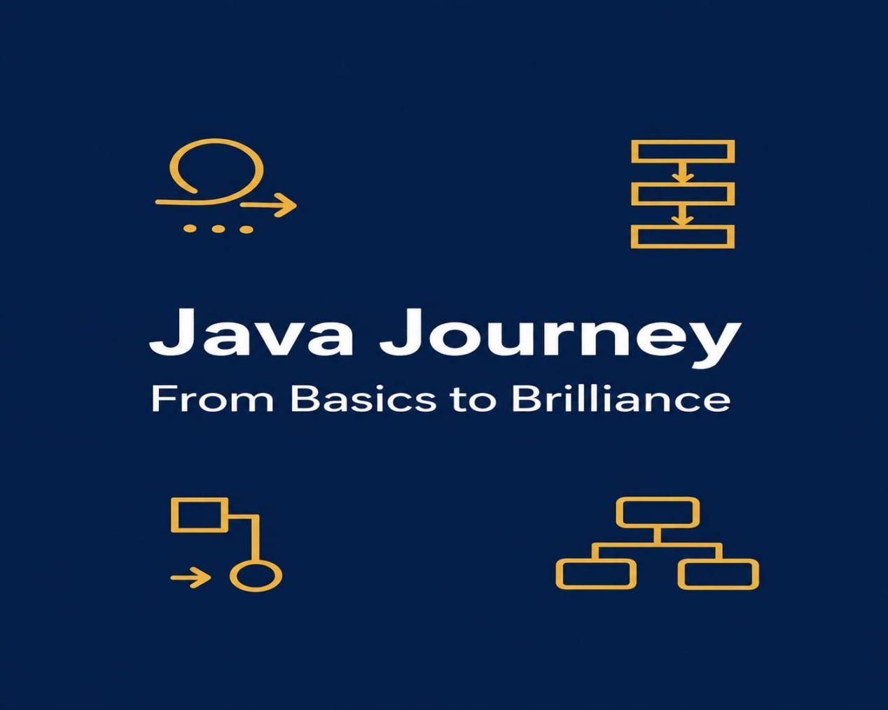

①The Fundamentals of Java
②Object Oriented Programming
③Data Structures and Algorithms

By Jawad Jammoul

